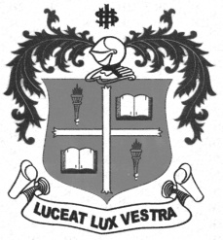
LOYOLA COLLEGE (AUTONOMOUS), CHENNAI – 600 034
B.A. DEGREE EXAMINATION – HISTORY
FIFTH SEMESTER – NOVEMBER 2012

HT 5403 - WESTERN POLITICAL THOUGHT

Date : 16/11/2012 Dept. No. Max. : 100 Marks
Time : 9:00 - 12:00

PART-A
Write a note on any TEN of the following in ten lines each: (10x2=20)

- Life Sketch of Plato
- Athenian Democracy
- Thrasymachus Idea of Radicalism
- Final goal of Communism
- Rousseau and Republic
- Significant Functions of Hobbes’ Sovereign
- Liberty and Rights of Hobbes
- Marxian Classwar
- Materialism of Marx
- State of Nature of Rousseau
- Origin of Western Political Thought
- Methodology Employed in Plato’s Dialogues

PART-B
Answer any FOUR of the following in two pages each: (4x10=40)

- What are the available works of Plato’s Dialogue?
- Elucidate the Sovereignty of Hobbes.
- Sketch the special features of Western Political Thought.
- Discuss the idea of Plato on Politics, Virtue Knowledge and Reality.
- Explain the concept of Aristotle on Revolution.
- Analyze the operation of Dialectical Materialism of Marx in Indian context

PART-C
Answer any TWO of the following in four pages each: (2x20=40)

- Explain the process followed by Plato to formulate his theory of Justice.
- Narrate the salient features of Rousseau’s Social Contract.
- Describe the Communist Ideology of Karl Marx.
- Discuss the Origin of the State of Aristotle.

